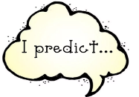
Week 2 Day 1 – Reading – Summarise and Predict
This week, you will be reading ‘Greta and the Giants’ as part of your reading lessons. Look at the front cover. For today’s lesson, we would like you to predict what you think the story is going to be about.

Look at the front cover carefully. What do you think the story will be about? How do you know?
Use the language structures to help you write your answers and email them to dh.y4homelearning@perryhallmat.co.uk

I think the story will be about… because on the front cover…
I predict that the story will… because ….
In my opinion, the story will be about…
This is probably because…
I know that the story will….due to the fact that the front cover shows….
Afterwards I think that the…..because….

