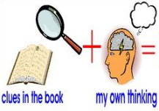
Week 3 Day 1 – Reading – Inference
This week, we will continue to focus on our class text ‘Greta and the Giants.’ Our reading skills focus is inference. Inference is an idea or decision we make based on the clues and evidence in the text.

Task A – Look at the front cover of the book. Around the picture, write down what you can see.

Using the picture on the front cover, write down:
● what you can infer from the picture
● how you think the characters are feeling.
Use these sentence starters to help you:
I infer that….because on the front cover…
I think that the character is feeling…because….
I believe that… This is because…
e.g. I infer that the animals are waiting for Greta to make a difference or change because on the front cover they are staring at Greta and their arms are in the air which shows they support her.
Once you have completed it, you can email your work: dh.y4homelearning@perryhallmat.co.uk

