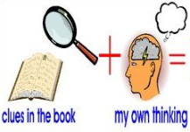
Week 3 Day 2 – Reading – Greta and the Giants
1) Write down what you can see in each picture.
2) What do you infer from the following pictures? When you are inferring, explain how you think the characters are feeling.
Use these sentence starters to help you:
I infer that… because in the picture I can see that…
I think that the character is feeling…because…
I believe that… This is because…
3) Once you have completed this task, you can email your work: dh.y4homelearning@perryhallmat.co.uk

e.g. I infer that Greta likes animals because she is holding up the owl and smiling.

