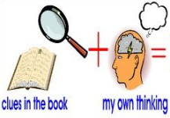
Week 3 Day 3 – Reading – Greta and the Giants
1) Read the text and answer the following inference questions. Remember to use our reading strategies to help you answer the questions.
- Read the question and read it again.
- Underline or circle the key information.
- Look for clues in the text.
- Check to see if your answer makes sense.
2) Use these sentence starters to help you:
I infer that… because in the picture I can see that…
I think that the character is feeling…because…
I believe that… This is because…
3) Once you have completed this task, you can email your work: dh.y4homelearning@perryhallmat.co.uk

1) How do you know that the animals were feeling scared and worried?

2) What evidence is there in the text that Greta is determined to carry on with her mission?

3) What evidence is there in the text and picture that the Giants might start to feel worried about what Greta was doing?

