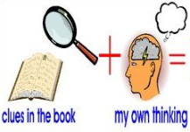
Week 3 Day 4 – Reading – Greta and the Giants
1) Read the text and answer the following inference questions. Remember to use our reading strategies to help you answer the questions.
- Read the question and read it again.
- Underline or circle the key information.
- Look for clues in the text.
- Check to see if your answer makes sense.
2) Use these sentence starters to help you:
I infer that… because in the picture I can see that…
I think that the character is feeling…because…
I believe that… This is because…
3) Once you have completed this task, you can email your work: dh.y4homelearning@perryhallmat.co.uk

1) How do you know that the Giants are being selfish?

2) What evidence is there in the text that Greta and her supporters are trying to plead with the Giants?

3) What evidence is there in the text and picture that the Giants felt guilty about what they had been doing to the forest?

