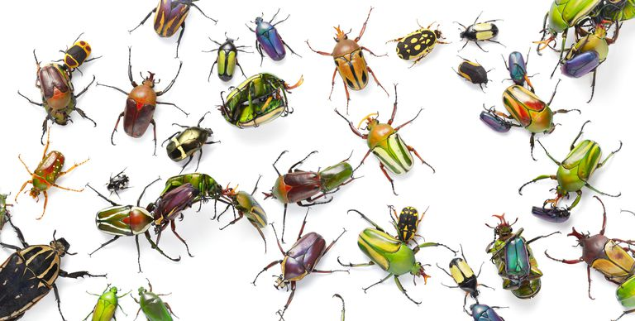
L.O. To use a key to identify invertebrates.
Read the PowerPoint linked on the home learning page, and then follow the instructions below:
1) As part of your one-hour daily exercise, or in your garden, go for walk and search for invertebrates (insects/bugs). Draw any invertebrates you find, identify the features and decide the name of the invertebrate.
2) Record your results in the tally chart below and create a bar chart to show how many of each invertebrate you have found.
3) When you have finished, please email your work to our email: dh.y4homelearning@perryhallmat.co.uk

Tally Chart – Create a tally chart for your results from the invertebrate hunt.
Invertebrate | Tally
beetle
ant
caterpillar
spider
slug
snail
worm
woodlouse

Bar Chart – Create a bar chart using your information from the tally chart.

_________________________________________________________________________________________________________________

____________________________________________________________________

