German – Week 6 – Countries of the World
In this lesson, you will learn how to say the names of different countries in German.
1) Watch this clip to learn the names of different countries in the world:
Practise saying the names of the different countries in German. Practise saying aloud which countries you have visited in German.
For example, Ich habe besucht Spanien – I have visited Spain.

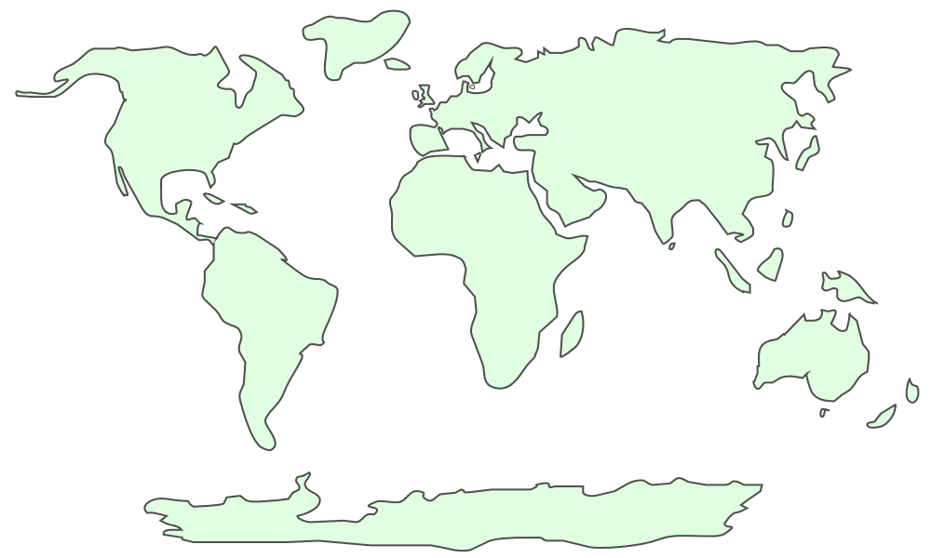
2) Use the world map poster to find countries that you have visited and write them on this world map in German. If you have not visited any other countries, choose four countries that you would like to visit and write their names on the world map in German.

3) In German, write a sentence to say which countries you have visited. See the example above for help.

4) Once you have completed your work email it to: dh.y4homelearning@perryhallmat.co.uk

