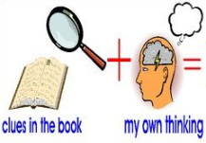
Week 4 Day 2 – Reading – Inference
This week, we have started a new class text called ‘The Boy at the Back of the Class.’ Our reading skill focus is inference. Inference is an idea or decision we make based on the clues and evidence in the text.

Task A – Look carefully at the front cover of the book. Around the picture, write down what you can see.
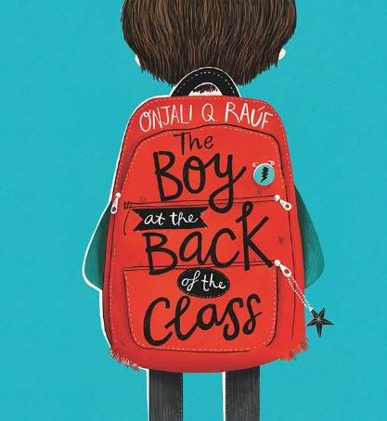

Task B – Using the picture on the front cover write down:
● what you can infer from the picture
● how you think the character is feeling

Use the sentence starters to help you.
I can infer that… because on the front cover…
I think that the character is feeling… because…
I believe that… This is because…
I think that the boy is… because…

Once you have completed it, you can email your work to us: dh.y4homelearning@perryhallmat.co.uk

