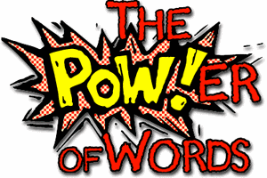
Week 4 Day 3 – Reading – Language
This week, we have started a new class text called ‘The Boy at the Back of the Class.’ Our reading skill focus for today is language. Language questions focus on the meaning of words and the effect words have on the reader.
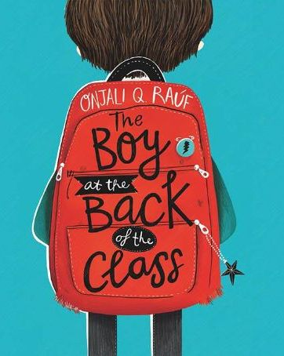
Task A – Read pages 1 and 2.

Task B – Underline any words or phrases that you do not know the meaning of.

Task C – Choose five of the words you have underlined. Find the meaning of the words and write them down.

Once you have completed it, you can email your work: dh.y4homelearning@perryhallmat.co.uk

