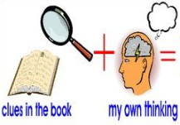
Week 4 Day 4 – Reading – The Boy at the Back of the Class
1) Read the text and answer the following inference questions. Remember to use our reading strategies to help you answer the questions.
- Read the question and read it again.
- Underline or circle the key information.
- Look for clues in the text.
- Check to see if your answer makes sense.
2) Use these sentence starters to help you:
I infer that… because in the picture I can see that…
I think that the character is feeling…because…
I believe that… This is because…
3) Once you have completed this task, you can email your work: dh.y4homelearning@perryhallmat.co.uk
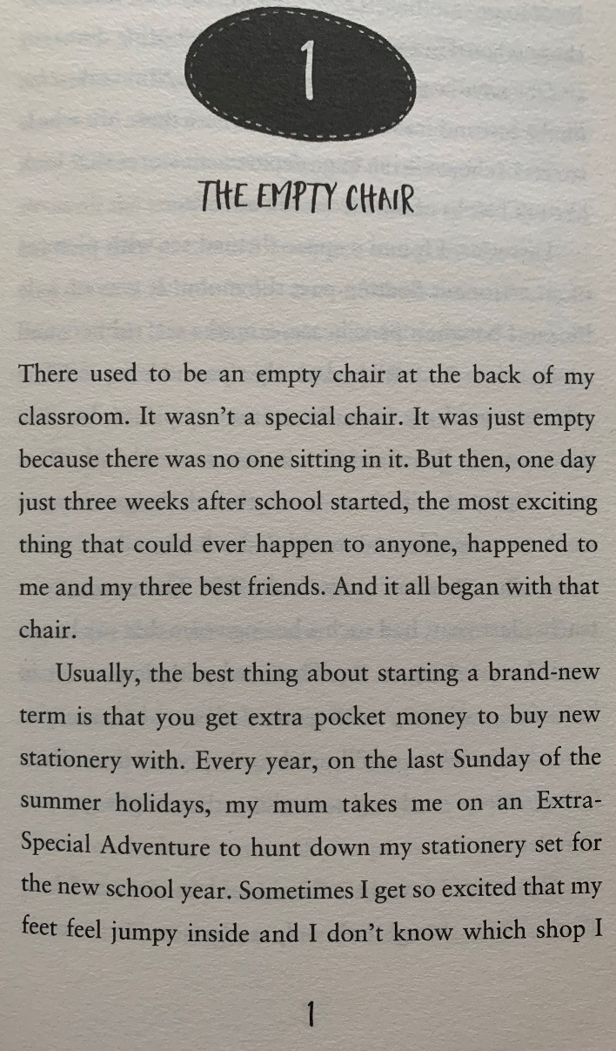

1) How do you know that the chair wasn’t a special chair?

2) What evidence is there in the text that the author is always excited about starting a brand new term?

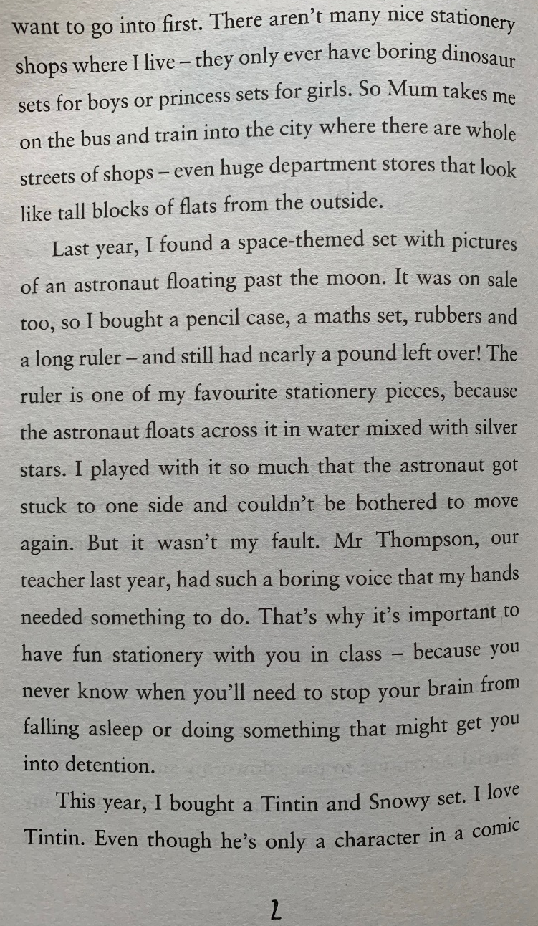
3) How do you know that the author enjoys going to the city to get his new stationery set?

4) What evidence is there in the text that the author likes to spend his money wisely?

5) Why do you think the author feels it is important to have a fun and exciting stationery set in class? Use evidence from the text to support your answer.

