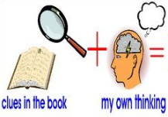
Week 5 Day 3 – Reading – The Boy at the Back of the Class
1) Read the text and answer the following inference questions. Remember to use our reading strategies to help you answer the questions.
- Read the question and read it again.
- Underline or circle the key information.
- Look for clues in the text.
- Check to see if your answer makes sense.
2) Use these sentence starters to help you:
I infer that… because in the picture I can see that…
I think that the character is feeling…because…
I believe that… This is because…
3) Once you have completed this task, you can email your work: dh.y4homelearning@perryhallmat.co.uk

1) How do you know that the author is a big fan of the comic character Tintin?

2) What evidence is there in the text that tells us that the author can only afford to buy a few items of stationery this year?

3) How do you know the author likes dogs even though he is allergic to them? Use evidence from the text to support your answer.

