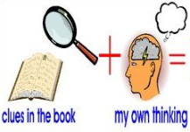
Week 5 Day 4 – Reading – The Boy at the Back of the Class
1) Read the text and answer the following inference questions. Remember to use our reading strategies to help you answer the questions.
- Read the question and read it again.
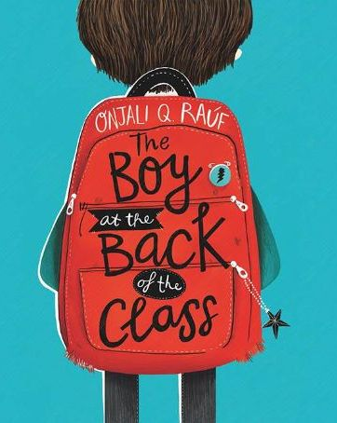
- Underline or circle the key information.
- Look for clues in the text.
- Check to see if your answer makes sense.
2) Use these sentence starters to help you:
I infer that… because in the picture I can see that…
I think that the character is feeling…because…
I believe that… This is because…
3) Once you have completed this task, you can email your work: dh.y4homelearning@perryhallmat.co.uk
1) What evidence is there in the text that the author doesn’t like asking for help in maths?

2) How do you know that the author has a clsoe group of friends?

3) What evidence is there in the text that Tom might not be getting enough food at home to eat?

4) Why do you think the author chooses to hide his food from Tom? Justify your answer using evdience from the text.

