L.O. To explore the characteristics of living things through a table and classification key.
 | Jaguar | Tapir | Toucan | Fruit Bat | Hummingbird | Tree frog | Anaconda | Caiman
Does it lay eggs?
Does it have scales?
Does it have wings?
Does it have a back?
Does it have legs?
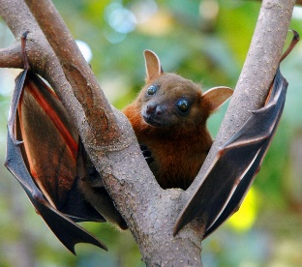
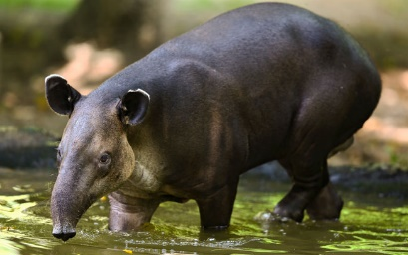
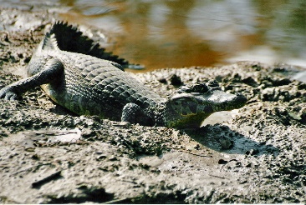
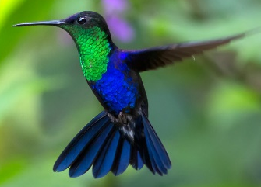
Task A – Rainforest Habitat Classification – Record which living thing has each characteristic by putting a tick or a cross in the table. Write your own questions in the last two boxes of the table.

Hummingbird Fruit bat Tapir Caiman

Task B – Woodland Habitat Classification – Record which living thing has each characteristic by putting a tick or a cross in the table. Write your own questions in the last two boxes of the table.
 | Bluebell | Badger | Owl | Woodpecker | Hedgehog | Oak Tree | Ant | Earthworm
Does it have wings?
Is it a vertebrate?
Does it have legs?
Does it have a trunk?
Does it have spines?

Task C – Arctic Habitat Classification – Record which living thing has each characteristic by putting a tick or a cross in the table. Write your own questions in the last two boxes of the table.
 | Polar Bear | Walrus | Beluga Whale | Narwhal | Puffin | Harp Seal | Snowy Owl | Reindeer
Does it have horns or tusks?
Does it have feathers?
Does it live in the ocean?

