Country Fact File
Find Greece on the map and colour it in.
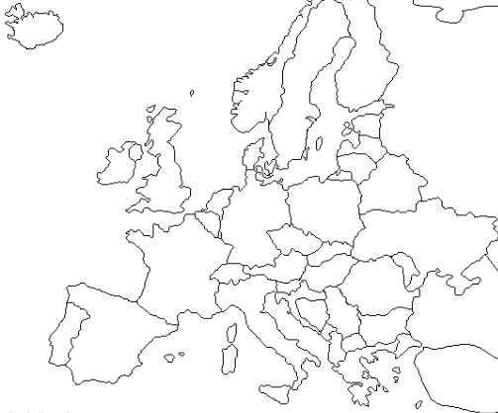

Capital City: __________________________ Population: _________________________

Continent: _______________________ Spoken Language(s): ______________________

How to say hello: ____________________ How to say thank you: ____________________

A famous person: ___________________________________________________________

An interesting fact: __________________________________________________________
Famous Landmark:
Flag:

