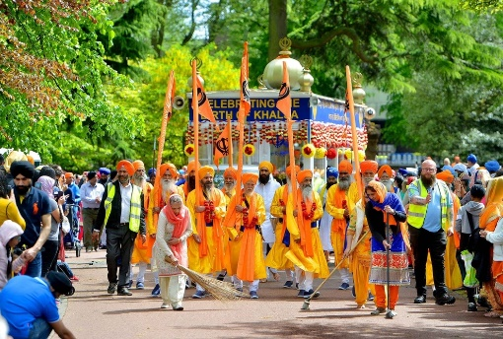
Religious Education – Week 7 – A Sikh celebration – Vaisakhi
In this lesson, you will be learning about a Sikh celebration called Vaisakhi.
1) Watch these clips to find out why and how Sikhs celebrate Vaisakhi:
- Link 1
- Link 2
2) Draw and label five things that are part of the Vaisakhi celebrations.
Explain why you think Vaisakhi is important to Sikhs.

Once you have completed it, you can email your work: dh.y4homelearning@perryhallmat.co.uk

