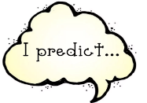
Week 10 Day 3 – Reading – Predict
1) Read page 17 again.

2) After reading page 17, make a prediction as to what you think will happen next. Justify your prediction with a reason from the text.
Use the language structures to help you with your prediction.

I predict that… because…

I think that… because...

I believe that…

Once you have completed it, you can email your work: dh.y4homelearning@perryhallmat.co.uk

