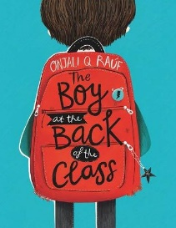
Week 10 Day 4 – Reading – Select and Retrieve
Read pages 16 and 17 again.

Answer the following questions.
- On page 16, why didn’t any of the class not learn about being a Roman gladiator?

- What happened to the new boy at break time?

- At the end of the day, who knew the new boy’s name?

- On page 17, what information did Clarissa give about the new boys reading and writing ability?

- What is Jennie famous for in school?

- When was the football match that Josie was accused of cheating in?

- What was the bruise compared to?
Once you have completed it, you can email your work: dh.y4homelearning@perryhallmat.co.uk

