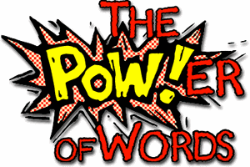
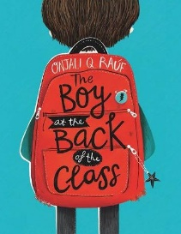
Week 7 Day 2 – Reading – Language and Retrieval
1) Read the following page of the story again.
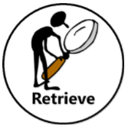
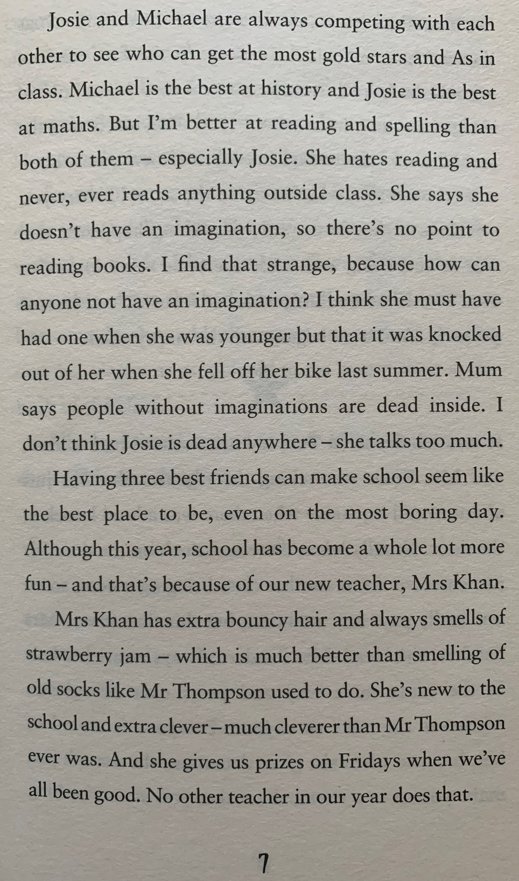

2) Decide whether each question is a retrieval question (R) or a language question (L) and write it in the column before answering the question.

R/L | Question
 | Who is the best at history?
 | Find and copy a word that means the same as dislike.
 | Explain the meaning of the word strange.
 | Explain when Josie fell off her bike.
 | When do the children receive prizes?
 | Find and copy a word in the text that means the same as intelligent.

3) Once you have completed it, you can email your work: dh.y4homelearning@perryhallmat.co.uk

