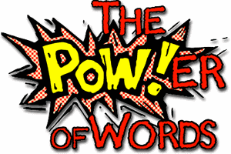
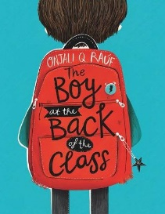
Week 7 Day 3 – Reading – Language
1) Read the following page of the story.
2) Underline at least three words that you do not know the meaning of.
3) Explain what you think the word means and find the meaning in a dictionary or online.
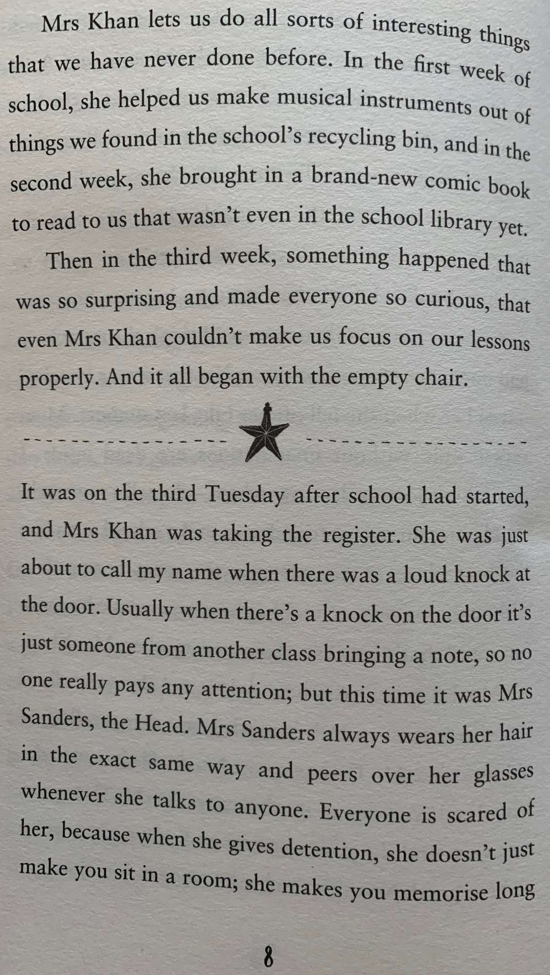
a) New word
I think it means

Dictionary/online definition

b) New word
I think it means

Dictionary/online definition

c) New word
I think it means

Dictionary/online definition

Once you have completed it, you can email your work: dh.y4homelearning@perryhallmat.co.uk

