Week 7 Day 4 – Reading – Retrieval and Language
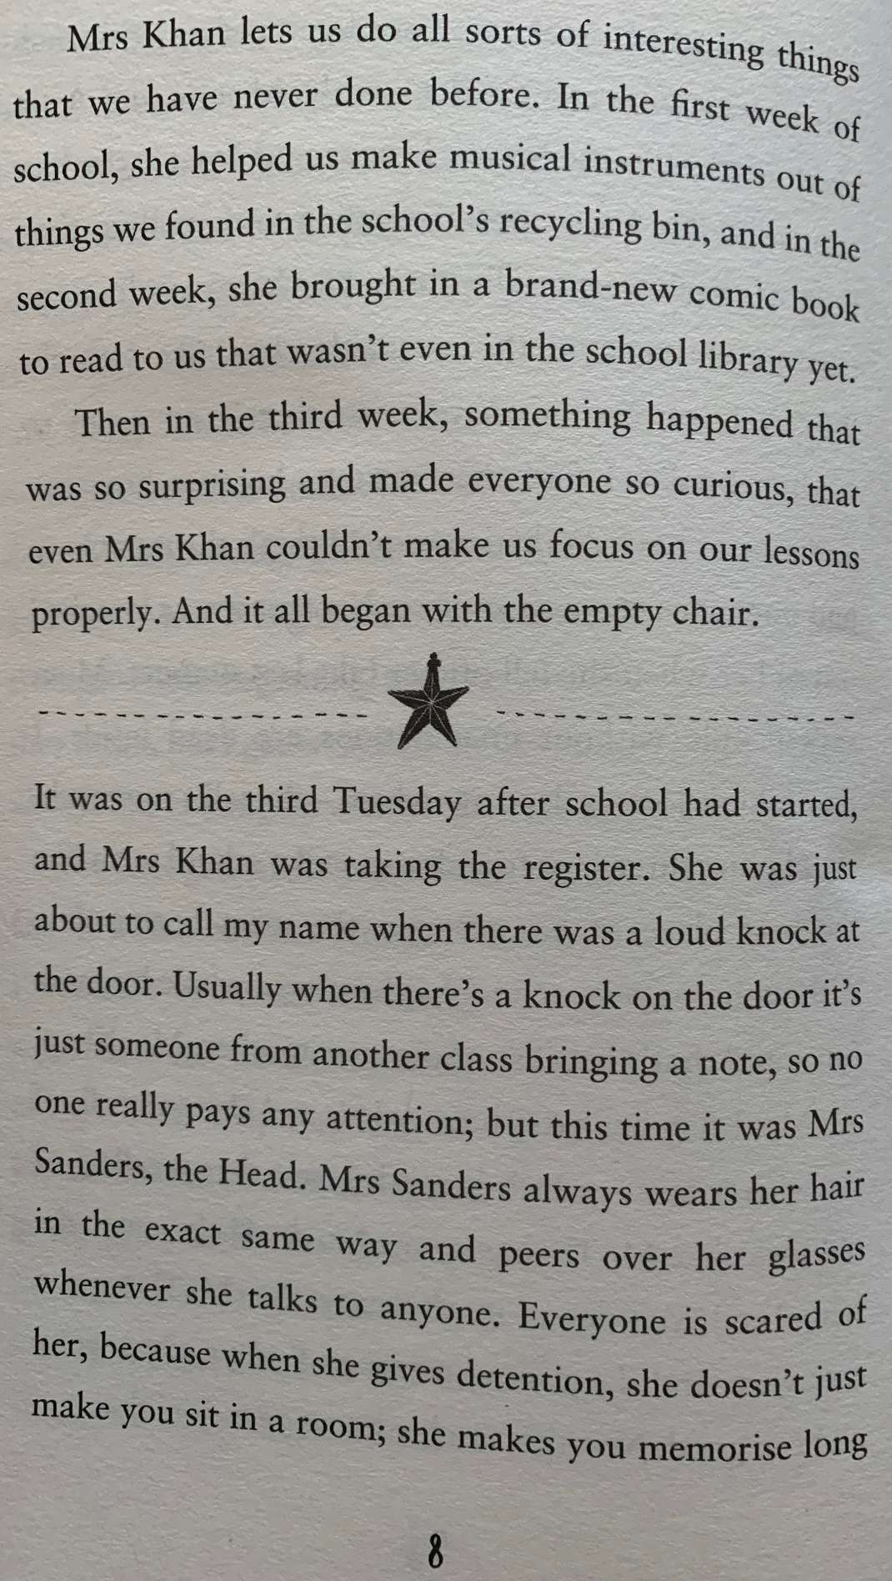
1) Read the following page of the story again.

2) Decide whether each question is a retrieval question (R) or a language question (L) and write it in the column.
3) Answer each question
R/L | Question
 | When did the children make musical instruments out of recycling materials found in the school bin?
 | Find and copy a word in the text that means the same as being eager or keen to know something.
 | Write the word from the text that is an antonym for full.
 | In the story, who is the head of the school?
 | What was Mrs Khan doing when there was a knock at the door?
 | Explain the meaning of the phrase ‘peers over her glasses whenever she talks to anyone’.

4) Once you have completed it, you can email your work: dh.y4homelearning@perryhallmat.co.uk

