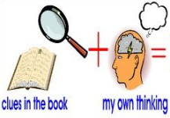
Week 8 Day 2 – Reading – Retrieval and Inference
1) Read the following pages of the story again.

2) Decide whether each question is a retrieval question (R) or an inference question (I) and write it in the column before answering the question.

R / I | Question
 | Where were lower graders stuck to learn words as long as a page?
 | How do you know that Mrs Sanders had something important to tell Mrs Khan? Use evidence from the text to justify your answer.
 | Who turned to look at the empty chair?
 | Why was the chair empty?
 | Why do you think that no one except her best friend missed Dena? Use the evidence from the text to justify your answer.
 | Who was Dena’s best friend?

3) Once you have completed it, you can email your work: dh.y4homelearning@perryhallmat.co.uk

