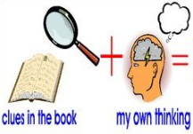
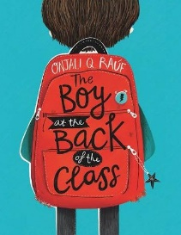
Week 8 Day 4 – Reading – Retrieval and Inference
1) Read the following pages of the story again.

2) Decide whether each question is a retrieval question (R) or an inference question (I) and write it in the column before answering the question.

R / I | Question
 | On page 11, what were Dena and her friend really doing at the back of the class?
 | On page 11, how do you know the chair had been left empty? Explain your answer using evidence from the text.
 | Where is the story set? How do you know?
 | On page 11, what is the name of the new boy?
 | On page 12, what evidence is there to show that Clarissa will not welcome the new boy sitting next to her?
 | On page 12, how can you tell that the new boy is probably feeling anxious about joining the class?

3) Once you have completed it, you can email your work: dh.y4homelearning@perryhallmat.co.uk

