Week 9 Day 2 – Reading – Retrieval, Language and Inference
1) Read the text again
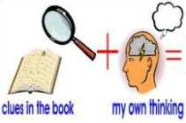
2) Use your definitions from yesterday to help you when you are reading.

3) Decide whether each of the questions in the table is a retrieval, language or inference question. Write R for retrieval, L for language or I for inference and then answer the question using all the reading strategies you have learnt.
R / L / I | Question
 | Explain the meaning of the word sneaking on page 13.
 | How do you think the new boy was feeling when he entered the classroom? Explain your answer using evidence from the text.
 | Find and copy an antonym on page 13 for high.
 | What colour were the boy’s eyes?
 | How do you know that the boy’s eyes were special?
 | What are the new boy’s eyes compared to in the text?

4) Once you have completed it, you can email your work: dh.y4homelearning@perryhallmat.co.uk

