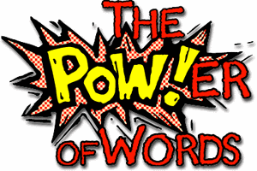
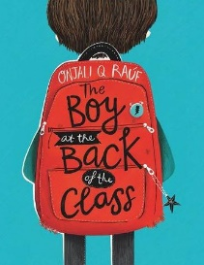
Week 9 Day 3 – Reading – Language
This week, we will continue to focus on our class text ‘The Boy at the Back of the Class’ by Onjali Q.Rauf. Make sure to reread the previous pages if you can’t remember what is happening.
1) Read the next part of the story.
2) Underline four words that you are not sure about the meaning of.
3) Write down what you think the meaning is and then look it up in a dictionary or online.

a) New word:
I think it means

Dictionary/online definition:

b) New word:
I think it means

Dictionary/online definition:

c) New word:
I think it means

Dictionary/online definition:

d) New word:
I think it means

Dictionary/online definition:

Once you have completed it, you can email your work: dh.y4homelearning@perryhallmat.co.uk

