Week 9 Day 4 – Reading – Retrieval, Language and Inference
1) Read the text again
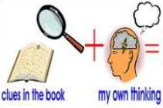
2) Use your definitions from yesterday to help you when you are reading.

3) Decide whether each of the questions in the table is a retrieval, language or inference question. Write R for retrieval, L for language or I for inference and then answer the question using all the reading strategies you have learnt.
R / L / I | Question
 | Where does the author imagine Tom had come from?
 | What colour was the boy’s rucksack?
 | Find and copy a word on page 14 that means the same as filthy.
 | Read the sentence ‘I tried my best to jump over the vault in one go in front of the new boy’. Why do you think the author does this?
 | What lesson did they have in the afternoon?
 | Find and copy a synonym on page 15 for permitted.

4) Once you have completed it, you can email your work: dh.y4homelearning@perryhallmat.co.uk

