History – Week 12 – The Tudors
In this lesson, you will be learning about the wives of Henry VIII. Read the PowerPoint to find out more about his wives.
Watch the following clip to learn the song to help you remember the names of his wives and the order in which he married them.
When Henry VIII’s third wife, Jane Seymour died, he was sent paintings of noble and royal women to look so that he could choose a new wife. Draw a portrait of a potential wife for Henry VIII.
Add personal details to give Henry more information about the potential wife. You can use the images of his wives to help you with drawing your own portrait.
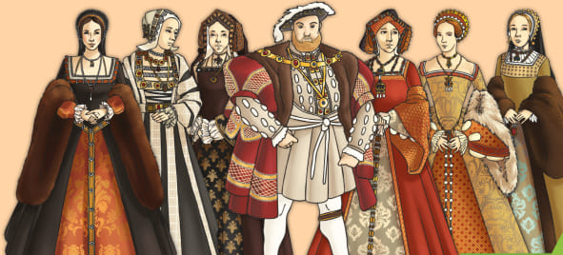
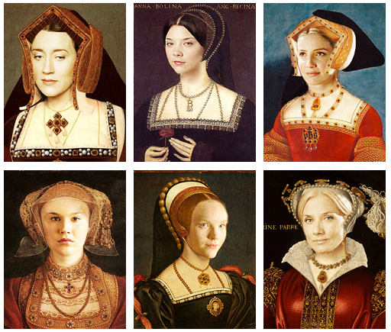

Once you have completed your work, email it to:dh.y4homelearning@perryhallmat.co.uk

A New Wife for Henry VIII
When Henry VIII’s third wife, Jane Seymour died, he was sent paintings of noble and royal women to look at so that he could choose a new wife. Draw a portrait of a potential wife for Henry VIII.

Name: ____________________________________________________________________________
Age: __________________________
Nationality: ________________________________________________________
Hobbies: ______________________________________________________________________________________________
Dislikes: ________________________________________________________________________________________________

