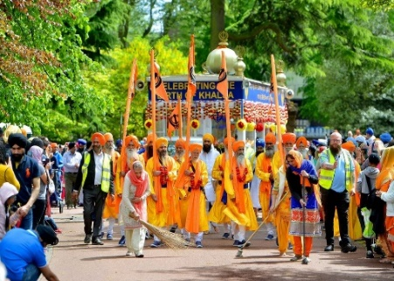
RE – Week 11 – Celebrations

1) As you have come to the end of the celebrations topic in RE, you will reflect on the three celebrations that you have learn about:
● Eid
● Vaisakhi
● Easter
In this lesson, you will explain what you have learnt about each of the celebrations. You can use the PowerPoints and video clips from previous learning to remind yourself about the different celebrations.
Link 1 Link 2 Link 3 Link 4

2) Using the symbols for each celebration, write down words around the symbol to represent that particular celebration. Write a sentence explaining what each celebration means to the particular group of people following it.
What does Eid-ul-fitr mean for Muslims?

What does Guru Nanak’s birthday and Vaisakhi mean to Sikhs?
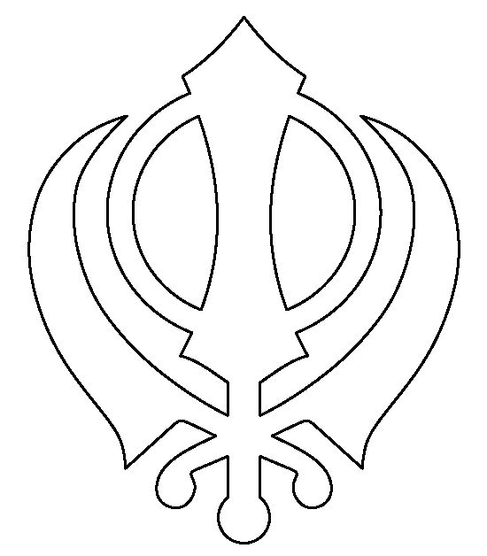

What does Easter mean for Christians?

3) Remember to email your work: dh.y4homelearning@perryhallmat.co.uk

