Week 11 Day 2 – Reading – Retrieval, Language and Inference
1) Read the text again
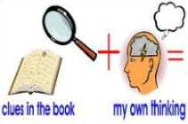
2) Use your synonyms from yesterday to help you when you are reading.

3) Decide whether each of the questions in the table is a retrieval, language or inference question. Write R for retrieval, L for language or I for inference and then answer the question using all the reading strategies you have learnt.
R / L / I | Question
 | Explain the meaning of the word politician on page 18.
 | Why does the author think that Jennie will be a good politician when she grows up?
 | Find and copy an antonym on page 18 for difficult.
 | Apart from Mrs Khan, name two other teachers that worked at the school.
 | On page 19, how you can tell that the woman that was waiting by the outdoor benches is not the new boys mum?
 | What was the woman who had come to collect the new boy wearing?
 | Find and copy a word on page 19 that means the same as nervous or timid.

4) Once you have completed it, you can email your work: dh.y4homelearning@perryhallmat.co.uk

