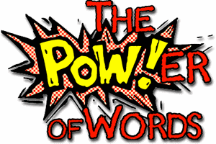
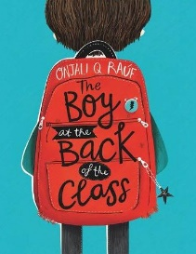
Week 11 Day 3 – Reading – Language
1) Read the next part of the story.
2) Underline four words that you are not sure about the meaning of.
3) Write down what you think the meaning is and then look it up in a dictionary or online.

a) New word:
I think it means

Dictionary/online definition:

b) New word:
I think it means

Dictionary/online definition:

c) New word:
I think it means

Dictionary/online definition:

d) New word:
I think it means

Dictionary/online definition:

Once you have completed it, you can email your work: dh.y4homelearning@perryhallmat.co.uk

