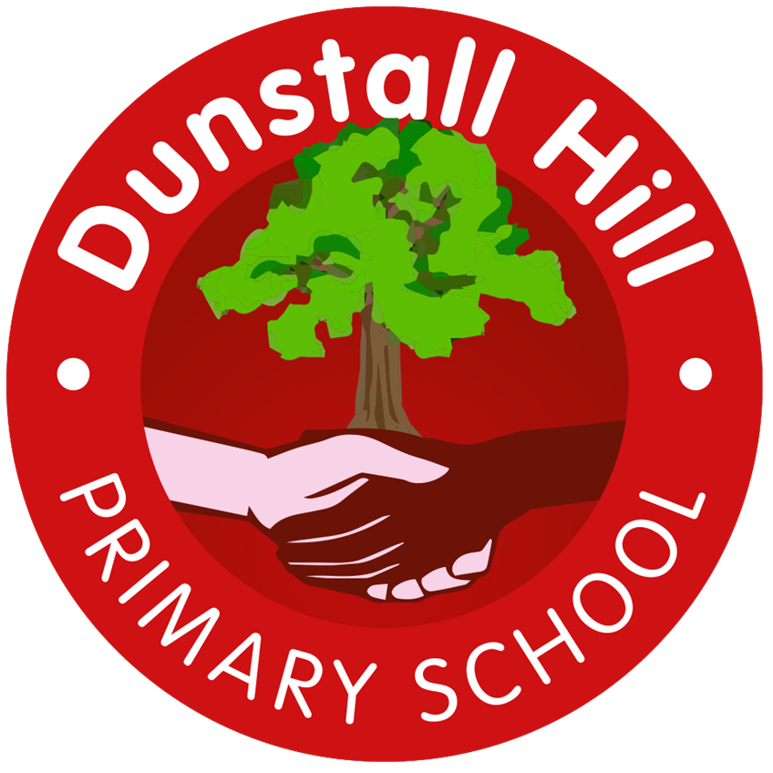
Dunstall Hill Primary School – Long Term Planning – Year 5 [2025 – 2026]
 | Autumn 1 | Autumn 2 | Spring 1 | Spring | Summer 1 | Summer 2
Visits/Visitors | The Secret Garden – Theatre Performance | Local Library Visit  Robin Hood Pantomime | Waterloo Road Mosque | Singing in the Halls | Black Country Living Museum | Local Walk – Geography Fieldwork
Parental Engagement |  |  | TBC | TBC | TBC | Sports Day
Science | Materials | Living Things | Forces | Astronomy | Meteorology | The Human Body
Geography | Spatial Sense | Mountains | UK Geography: East Anglia, The Midlands, Yorkshire and Humberside | Australia |  | Local Study
History | Baghdad 900CE | The Early British Empire | The Transatlantic Slave Trade | The Industrial Revolution |  | The Victorian Age
Art | Style in Art  Drawing/Painting | Islamic Art & Architecture  Drawing/Painting/3D Form | Art from Western Africa  3D Form/Drawing |  | Chinese Painting & Ceramics  Painting | Print Making  Printing
Design & Technology | Sew  Bags |  | Cook  Pitta Bread | Cook  Honey Cake |  | Build  CAMS Toys
Computing | Data & Information  Flat-file Databases  Laptops | Creating Media  Video Production  iPads | Creating Media  Introduction to Vector Graphics  Laptops | Programming  Selection in Physical Computing  Laptops | Computing Systems & Networks  Systems and Searching  iPads/laptops | Programming  Selection in Quizzes  Laptops
Music | The Lark Ascending | This Little Babe | Jin Go La Ba | Beethoven’s Eroica | African American Spirituals | English Folk Songs
PE | Fitness | Dance  OAA | Swimming | Striking & Fielding – Cricket  Swimming | Net & Wall - Badminton | Yoga  Invasion Games – Basketball
PSHE | Me & My Relationships | Valuing Difference  L5 & L6 – Removed from Y5 | Keeping Safe  L5 – Removed from Y5 | Rights & Respect | Being My Best | Growing & Changing  L5 – Removed from Y5  Puberty Talk – School Nurse – All*
RE | Why do people have to stand up for what they believe in? | Why doesn’t Christianity always look the same? | What happens when we die? (Part 1) | What happens when we die? (Part 2) | Who should get to be in charge? | Why are some places in the world significant to believers?
MfL | Chez moi |  | Les vêtements |  | Quel temps fait-il

