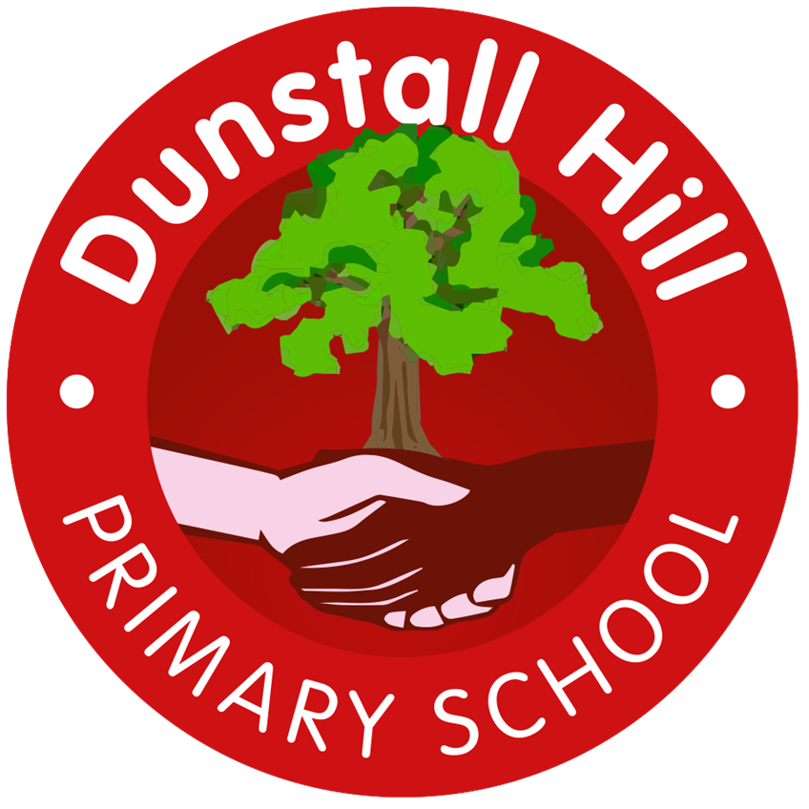
Dunstall Hill Primary School – Long Term Planning – Year 4 [2025 – 2026]
 | Autumn 1 | Autumn 2 | Spring 1 | Spring 2 | Summer 1 | Summer 2
Visits/Visitors | Local Area Study – Geography Fieldwork  Into Film Festival – Cinema  The Secret Garden – Theatre Performance | Bright Sparks – Fire Brigade  Robin Hood Pantomime | Bishops Wood |  | Cadbury World
Parental Engagement |  | Multiplication Tables Check Workshop |  | TBC |  | TBC  Sports Day
Science | The Human Body | Classification of Plants & Animals | Ecology | Sound | The Water Cycle | Electricity
Geography | Spatial Sense | Mediterranean Europe | Eastern Europe |  | UK Geography: London and the South East
History | Ancient Greece | Life in Ancient Rome | The Rise and Fall of Ancient Rome |  | The Stuarts
Art | Light  Drawing/Painting | Space  3D Form/Drawing | Design  Drawing/Painting |  | Monuments of the Byzantine Empire  Painting/Collage | Needlework, Embroidery & Weaving  Textiles
Design & Technology |  | Sew  Cushions | Build  Moving Miniature Playgrounds | Cook  Ratatouille & Couscous |  | Cook  Apple Crumble
Computing | Creating Media  Audio Production  Laptops | Creating Media  Photo Editing  Laptops | Computing Systems & Networks  The Internet  iPads/laptops | Data & Information Data Logging  iPads/laptops | Programming  Repetition in Shapes  Laptops | Programming  Repetition in Games  Laptops
Music | Stories in Sound 2  (Y3) | Pachabel’s Cannon  (Y3) | Classical Indian  (Y3) | Working Songs | Take a Train | Beethoven’s 5th
PE | Dance  Athletics | OAA | Gymnastics  Invasion Games - Netball | Striking & Fielding - Cricket | Target Games – Golf  Swimming | Swimming
PSHE | Me & My Relationships | Valuing Difference | Keeping Safe  L3 – Moved to Y2 | Rights & Respect | Being My Best | Growing & Changing  L, L4 & L6 – Removed from Y4  L3 – Moved from Y2  School Nurse – Puberty Talk*
RE | Are all religions equal? | What makes some texts sacred? | Just how important are our beliefs? | Who was Jesus really? | Why is the Bible the best-selling book of all time? | Does the language of scripture matter?
MfL | Ma Famille |  | As-tu un animal? |  | En classe

