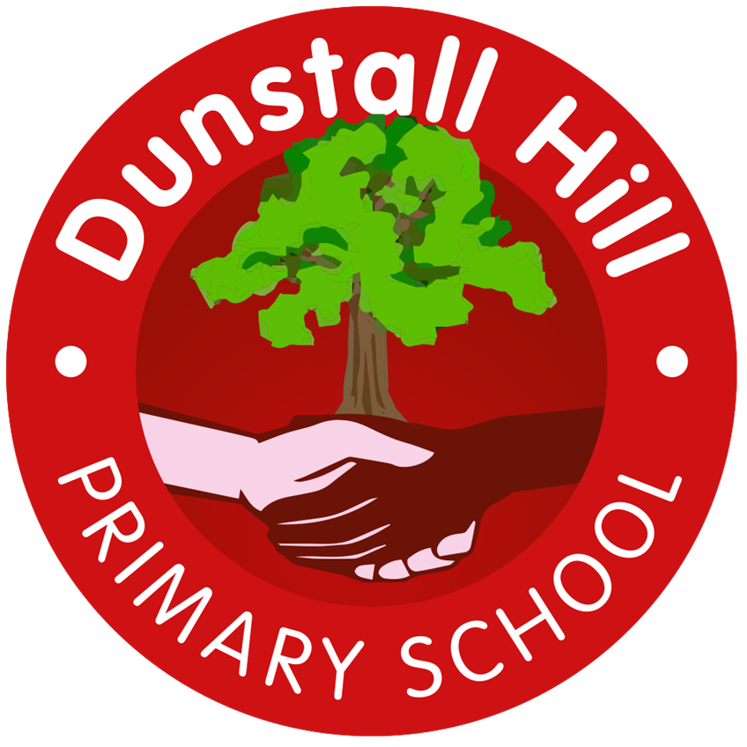
Dunstall Hill Primary School – Long Term Planning – Year 1 (2025 – 2026)
 | Autumn 1 | Autumn 2 | Spring 1 | Spring 2 | Summer 1 | Summer 2
Visits/Visitors | The Secret Garden – Theatre Performance | Robin Hood Pantomime |  | Hoo Zoo & Dinosaur World | West Park | Hoo Zoo and Dinosaur World
Parental Engagement | Phonics Screen Workshop |  | TBC |  | TBC
Science | The Human Body | Animals and their Needs | Seasons and Weather | Taking Care of the Earth | Plants | Materials & Magnets
Geography | Spatial Sense |  | The UK |  | Seven Continents
History |  | Discovering History |  | Kings, Queens & Leaders |  | Parliament & Prime Ministers
Art | Colour  Painting/Mixed Media | Line  Drawing/Mixed Media | Architecture  Drawing/3D Form/ Collage | Styles in Art  Painting/Drawing | Paintings of Children  Painting/Drawing/Collage | Sculpture  Drawing/3D Form
Design & Technology | Cook  Jam Tarts | Cook  Dips and Vegetables | Sew  Animal Sock Puppets |  | Build  Vehicles
Computing | Computing Systems & Networks  Technology around Us  Unplugged | Creating Media  Digital Painting  Laptops | Programming  Moving a Robot  Beebots | Data & Information Grouping Data  Unplugged/iPads | Creating Media  Digital Writing  Laptops | Programming  Programming Animations  iPads/laptops
Music | Marching Music | Samba | Animals in Music | Ostinato 1 | What Can You Hear? | Stories in Sound 1
PE | Fundamental skills | Ball Skills  Athletics | Gymnastics  1RC Balancability | Dance  1PH Balancability | Sending & Receiving  Invasion Games | Net & Wall Games
PSHE | Me & My Relationships | Valuing Difference | Keeping Safe  L3 – Moved to Y2 | Rights & Respect | Being My Best | Growing & Changing  L6 – Moved to Y2
RE | How did the World begin? | What do some people believe God looks like? | What is God’s job? | Why should we care for the world? | How do we know that new babies are special? | Why should we care for others?
Outdoor Learning | Children access Forest School every Thursday afternoon

