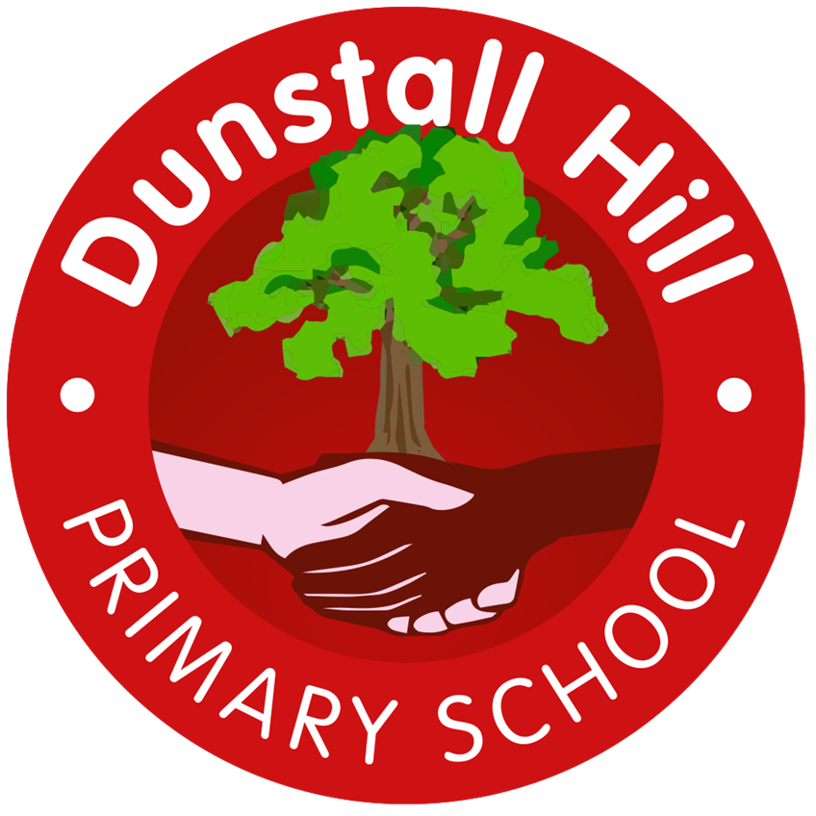
Dunstall Hill Primary School – Long Term Planning – Year 3 [2025 – 2026]
 | Autumn 1 | Autumn 2 | Spring 1 | Spring 2 | Summer 1 | Summer 2
Visits/Visitors | The Children’s Bookshow  The Secret Garden – Theatre Performance | Robin Hood Pantomime | River Study – Geography Fieldwork |  | Wren’s Nest National Nature Reserve
Parental Engagement | D&T Sewing Workshop | Multiplication Tables Check Workshop  Music Concert |  | TBC  Music Concert |  | Music Concert  Sports Day
Science | The Human Body | Cycles in Nature | Rocks | Forces & Magnets | Plants | Light
Geography | Spatial Sense | Settlements | Rivers | UK Geography:  The South West | Western Europe | Asia: China & India
History | Stone Age to the Iron Age |  | Ancient Egypt | Anglo Saxons, Scots and the Vikings
Art | Line  Drawing/Printing | Still Life & Form  Drawing | Art of Ancient Egypt  3D Form/Drawing |  | Ango Saxon Art  Drawing/Painting/Collage | Architecture  Drawing/Sculpture/Collage
Design & Technology | Sew  Key Rings/Decorations |  | Build  Pop-Up Books | Cook  Bread & Butter |  | Cook  Pasta
Computing | Creating Media  Stop-frame Animations  iPads | Programming  Sequencing Sounds  iPads/laptops | Computing Systems & Networks  Connecting Computers  Unplugged | Data & Information  Branching Databases  iPads/laptops | Creating Media  Desktop Publishing  Laptops | Programming  Events and Actions in Programs  Laptops
Music | Wolverhampton Music Service – Every Tuesday Afternoon
PE | Y3/Y4 Fundamental Skills | Dance  Athletics | Y3/Y4 Ball Skills | Gymnastics  Target Games - Dodgeball | Target Games - Golf | Invasion Games – Football  Net & Wall – Tennis
PSHE | Me & My Relationships | Valuing Difference  L2 – Removed from Y3 | Keeping Safe | Rights & Respect | Being My Best | Growing & Changing  L4 – Removed from Y3  L5 – Moved from Y2
RE | What makes us human? | Where do our morals come from? | Is scripture central to religion? | What happens if we do wrong? | Why is water symbolic? | Why is fire used ceremonially?
MfL | J’apprend le francais |  | Je peux (I am able to) |  | Les légumes

