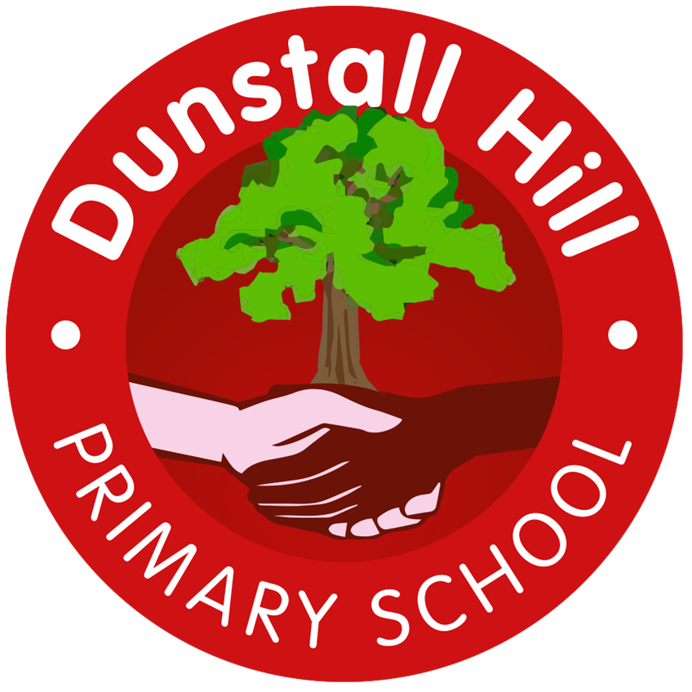
Dunstall Hill Primary School – Long Term Planning – Year 2 [2025 – 2026]
 | Autumn 1 | Autumn 2 | Spring 1 | Spring 2 | Summer 1 | Summer 2
Visits/Visitors | Canal Walk – Geography Fieldwork  The Secret Garden – Theatre Performance | Robin Hood Pantomime | Wolverhampton Art Gallery  Local Library Visit | Kingswood Trust
Parental Engagement |  | NumBots Workshop |  | SATS Workshop | TBC | Sports Day
Science | The Human Body | Living Things in their Environments | Electricity | Plants | Materials & Matter | Astronomy
Geography | Spatial Sense |  | The British Isles |  | Northern Europe
History |  | Roman in Britain |  | The Tudors |  | Powerful Voices
Art | Colour and Shape  3D Form/ Painting/Drawing | Colour, Shape & Texture  Collage/Drawing | Portraits and Self-Portraits  Drawing/Painting | Landscape & Symmetry  Mixed Media/Sculpture | History Painting  Drawing/Mixed Media | Murals & Tapestries  Printing/Textiles
Design & Technology | Cook  Pizza | Cook  Gingerbread |  | Sew  Pencil Cases |  | Build  Moving Pictures
Computing | Computing Systems & Networks  IT Around Us  Unplugged/iPads | Creating Media  Digital Photography  iPads | Programming  Robot Algorithms  Beebots | Data & Information  Pictograms  iPads | Creating Media  Digital Music  iPads/laptops | Programming  Programming Quizzes  iPads/laptops
Music | Ostinato 2 | Beat Music | Peter & the Wolf | Gamelan | Emotions in Sound | Off Beat
PE | Fundamental Skills  2MW Balancability | Yoga  2HW Balancability | Dance  Athletics | Ball Skills | Target Games | Invasion Games  Striking & Fielding Games
PSHE | Me & My Relationships | Valuing Difference | Keeping Safe  L4 – Moved from Y1 | Rights & Respect  L4 – Added from Project Evolve - eSafety | Being My Best | Growing & Changing  L4 – Moved from Y1  L5 and L6 – Removed from Y2
RE | Why do we need to give thanks? | What do candles mean to people? | How do we know some people feel a special connection to a god? | What is a prophet? | How do some people talk to God? | Where do some people talk?

